REPORT FOR: | CABINET
Date of Meeting: | 10 April 2014
Subject: | Appointment of Contractors to the Framework to Deliver Adaptations to all Tenures
Key Decision: | Yes
Responsible Officer: | Paul Najsarek, Corporate Director of Community, Health and Wellbeing
Portfolio Holder: | Councillor Barry Macleod-Cullinane, Deputy Leader and Portfolio Holder for Adults and Housing
Exempt: | No, except for the appendix which is exempt under paragraph 3 of Part I of Schedule 12A to the Local Government Act 1972 (as amended) in that it contains information relating to the financial or business affairs of any particular person (including the authority holding that information).
Decision subject to Call-in: | Yes
Enclosures: | Appendix - Procurement Report for the provision of Disabled Adaptations  (Exempt – Part II)



Section 1 – Summary and Recommendations

This report describes the outcome of the tender process to select contractors to the framework for the provision of Disabled Adaptations Services

Recommendations:

Cabinet is requested to:

- Approve the appointment of the following contractors to the framework agreement :

  - Amwell Construction Ltd
  - B & H Builders
  - C.E.Flynn Builders
  - Cameron Makenzie
  - David Martin Carpentry Contractors
  - Effectable Construction Services Limited
  - Expert Property Solutions
  - Euro Contracts (London) Ltd
  - F G Mileham Building Contractors Ltd

Field Brothers (Luton) Ltd

G & M Builders
  - H Carolan Construction
  - H D Property Services Limited
  - Jeffery & Wilkes Building Contractors Ltd
  - Mark Brown Builders
  - Mullin & Sons Ltd
  - R & R Builders
  - Terry and Stephens.

- Agree the commencement of the Framework from 1st May 2014 for a period of four years (3 years with the option to extend for a further 1 year subject to performance review and Council agreement) for the provision of Disabled Adaptations.

REASON:

For several years the council has been using an approved list of mostly small to medium sized local contractors to deliver this service. A formal tendering process was undertaken to formalise arrangements that would facilitate mini-competition amongst contractors who have already been through a competitive process.

In compliance with the Councils Standing Orders an open tendering procedure has been followed and based on the results a recommendation is made to award the contracts to the most economically advantageous tenders.

Section 2 – Report

- Background

  - The Council currently undertakes Adaptations via an approved list of contractors, which includes a number of contractors; these contractors are invited to tender for individual projects on a rotation basis; a minimum of 3 contractors are invited with the most financially advantageous contractor selected to carry out the works, it is recognised that this does give value for money however there is currently no compliant framework in place.

  - The procurement process was undertaken to gain a more efficient arrangement for delivering the Disabled Adaptations service. It provided the opportunity for a detailed specification to be created that clearly outlined the service required and the standard to which those are expected to be delivered. The aim of the exercise was to select 20 contractors with a range of specialisms that would allow for further mini-competitions to gain ongoing efficiency and continuous improvement.

  - The procurement process targeted a mixture of local as well as incumbent contractors. To ensure that these contractors had total clarity about the Council’s requirements an open day was held. This also provided the opportunity for interested contractors to clarify items of concern. A total of 25 contractors were invited to take part in the process. A total of 21 bids were received and subsequently evaluated by a panel consisting of both the Adaptations Team and Procurement representatives.

  - The evaluation was conducted against an evaluation mechanism that was based on a level 1 criteria of quality and price assessment with quality having a 70% weighting and price 30%. This was further broken down to the key assessment sub-criteria as follows:

 | Evaluation Criteria | Level 1 (%)
 | Quality | 70
 | Level Access shower
 | External Ramps
 | Working with Vulnerable Clients
 | Dealing with unforeseen delays
 | Dealing with reported theft
 | Price | 30
 | Mark-up and goods and materials
 | Mark-up on subcontracted services
 | Hourly labour rates (including adjustments for overheads and margins
 | Total | 100

  - The procurement project identified a number of opportunities that could flow from the procurement strategy, these included;
- Supporting the local economy
- Providing competition between suppliers to maintain quality and minimise price
- Encouraging innovation in service delivery

- Proposals and reasons

  - Following the evaluation process, the following 18 contractors met the threshold score required for entry to the Disabled Adaptations framework.

- Amwell Construction Ltd
- B & H Builders
- C.E.Flynn Builders
- Cameron Makenzie
- David Martin Carpentry Contractors
- Effectable Construction Services Limited
- Expert Property Solutions
- Euro Contracts (London) Ltd

F G Mileham Building Contractors

Field Brothers (Luton) Ltd

G & M Builders
- H Carolan Construction
- H D Property Services Limited
- Jeffery & Wilkes Building Contractors Ltd
- Mark Brown Builders
- Mullin & Sons Ltd
- R & R Builders
- Terry and Stephens

  - These contractors offered competitive hourly rates as well as mark-up rates for variations.

  - It is to be noted that 70% of the contractors selected are local and all contractors have signed up to employ local labour.

  - The suite of legal documents that underpin the framework has a range of key performance indicators built around performing to a specified standard, these are evaluated at the end of each individual contract, these are evaluated on various criteria, a copy of the completion assessment form is included in the appendix.

- TUPE

  - TUPE does not apply to this Framework as no single entity was delivering this service as the majority of its work.

- Legal Implications

As the works are carried out under individual contracts with a value well below the EU financial threshold for public works contracts above which a fully compliant EU tender process would have to be followed, the council has lawfully procured the framework agreement.

  - The council will need to put in place the framework agreement and call off contracts to protect the council’s legal and commercial interests.

- Financial Implications

  - The total value for this framework is estimated to be up to £8,600,000, based on a capital budget for Disabled Facilities Grants of £1.5m per year and Council Adaptations of £615,000 with the framework lasting 3 years with the option to extend for a further year.

- Performance Issues

  - This procurement exercise was mainly to formalise processes already in place. The service already exceeds both government recommended targets for delivery and the council’s commitment to keep within those timescales (recommendation 35 weeks). The graph below shows current performance .The procurement strategy adopted aimed to produce a result that would maintain this same performance and continue to provide both a cost effective adaptations service and support for the local economy. The procurement fits within the continuing transformation programme.

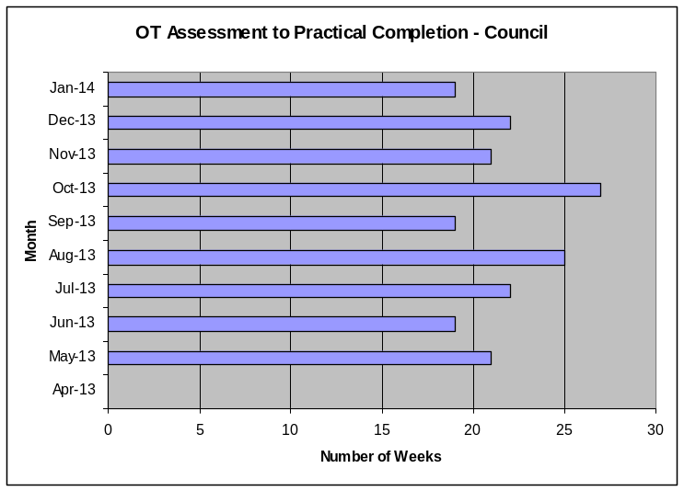

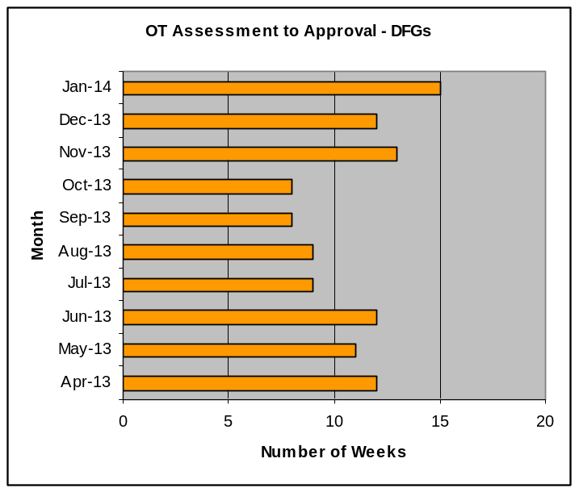

- Environmental Impact

  - This Contract is essentially for the provision of adaptations to allow people to remain in their own homes. However as part of the procurement exercise environmental factors were taken into account, these included improvements to the use of water and gas and the sourcing of materials from sustainable sources.

- Risk Management Implications

  - Risk included on Directorate risk register? No

  - Separate risk register in place? No

  - There are no new risks as this procurement exercise is only to formalise a process already in place.

- Equalities implications

9.1 There is no change to the policy that determines what adaptations should be provided and in what circumstances. That policy was adopted by Cabinet in April 2011 and was supported by an Equalities Impact Assessment.

The proposals in this report refer only to how the Council contracts to achieve the adaptations that the policy requires.

The contractors’ equalities policy were submitted and evaluated as part of the procurement process to ensure they met our standards, and equalities information was included in the tender.

- Corporate Priorities

  - This report incorporates the administration’s priorities to deliver a cleaner, safer and fairer Harrow by ensuring that households with disabilities have access to adaptations services provided by trusted contractors who will install adaptations as specified to meet specific need according to agreed standard and timescales.
  - As detailed in paragraph 6 the procurement exercise was undertaken fairly and targeted to produce a result that would maintain good performance and continue to provide both a cost effective adaptations service and support for the local economy.

Section 3 - Statutory Officer Clearance

 |  |  | on behalf of the
Name: Dave Roberts | x |  | Chief Financial Officer
Date: 5 March 2014
 |  |  | on behalf of the
Name: Puja Shah | x |  | Monitoring Officer
Date: 5 March 2014

Section 4 – Performance Officer Clearance

 |  |  | on behalf of the
Name: Jonathan Kilworth | x |  | Divisional Director
Date: 5 March 2014 |  |  | Strategic Commissioning

Section 5 – Environmental Impact Officer Clearance

 |  |  | on behalf of the
Name: Andrew Baker | x |  | Divisional Director
Date: 5 March 2014 |  |  | (Environmental Services)

Section 6 - Contact Details and Background Papers
Contact: Michael Sheehy, Service Manager - Adaptations & Repairs
Tel: 020 8736 6011 (ext 6011)
Email: Michael.Sheehy@harrow.gov.uk

Background Papers: None.

Call-In Waived by the Chairman of Overview and Scrutiny Committee |  | NOT APPLICABLE  [Call-in applies]

